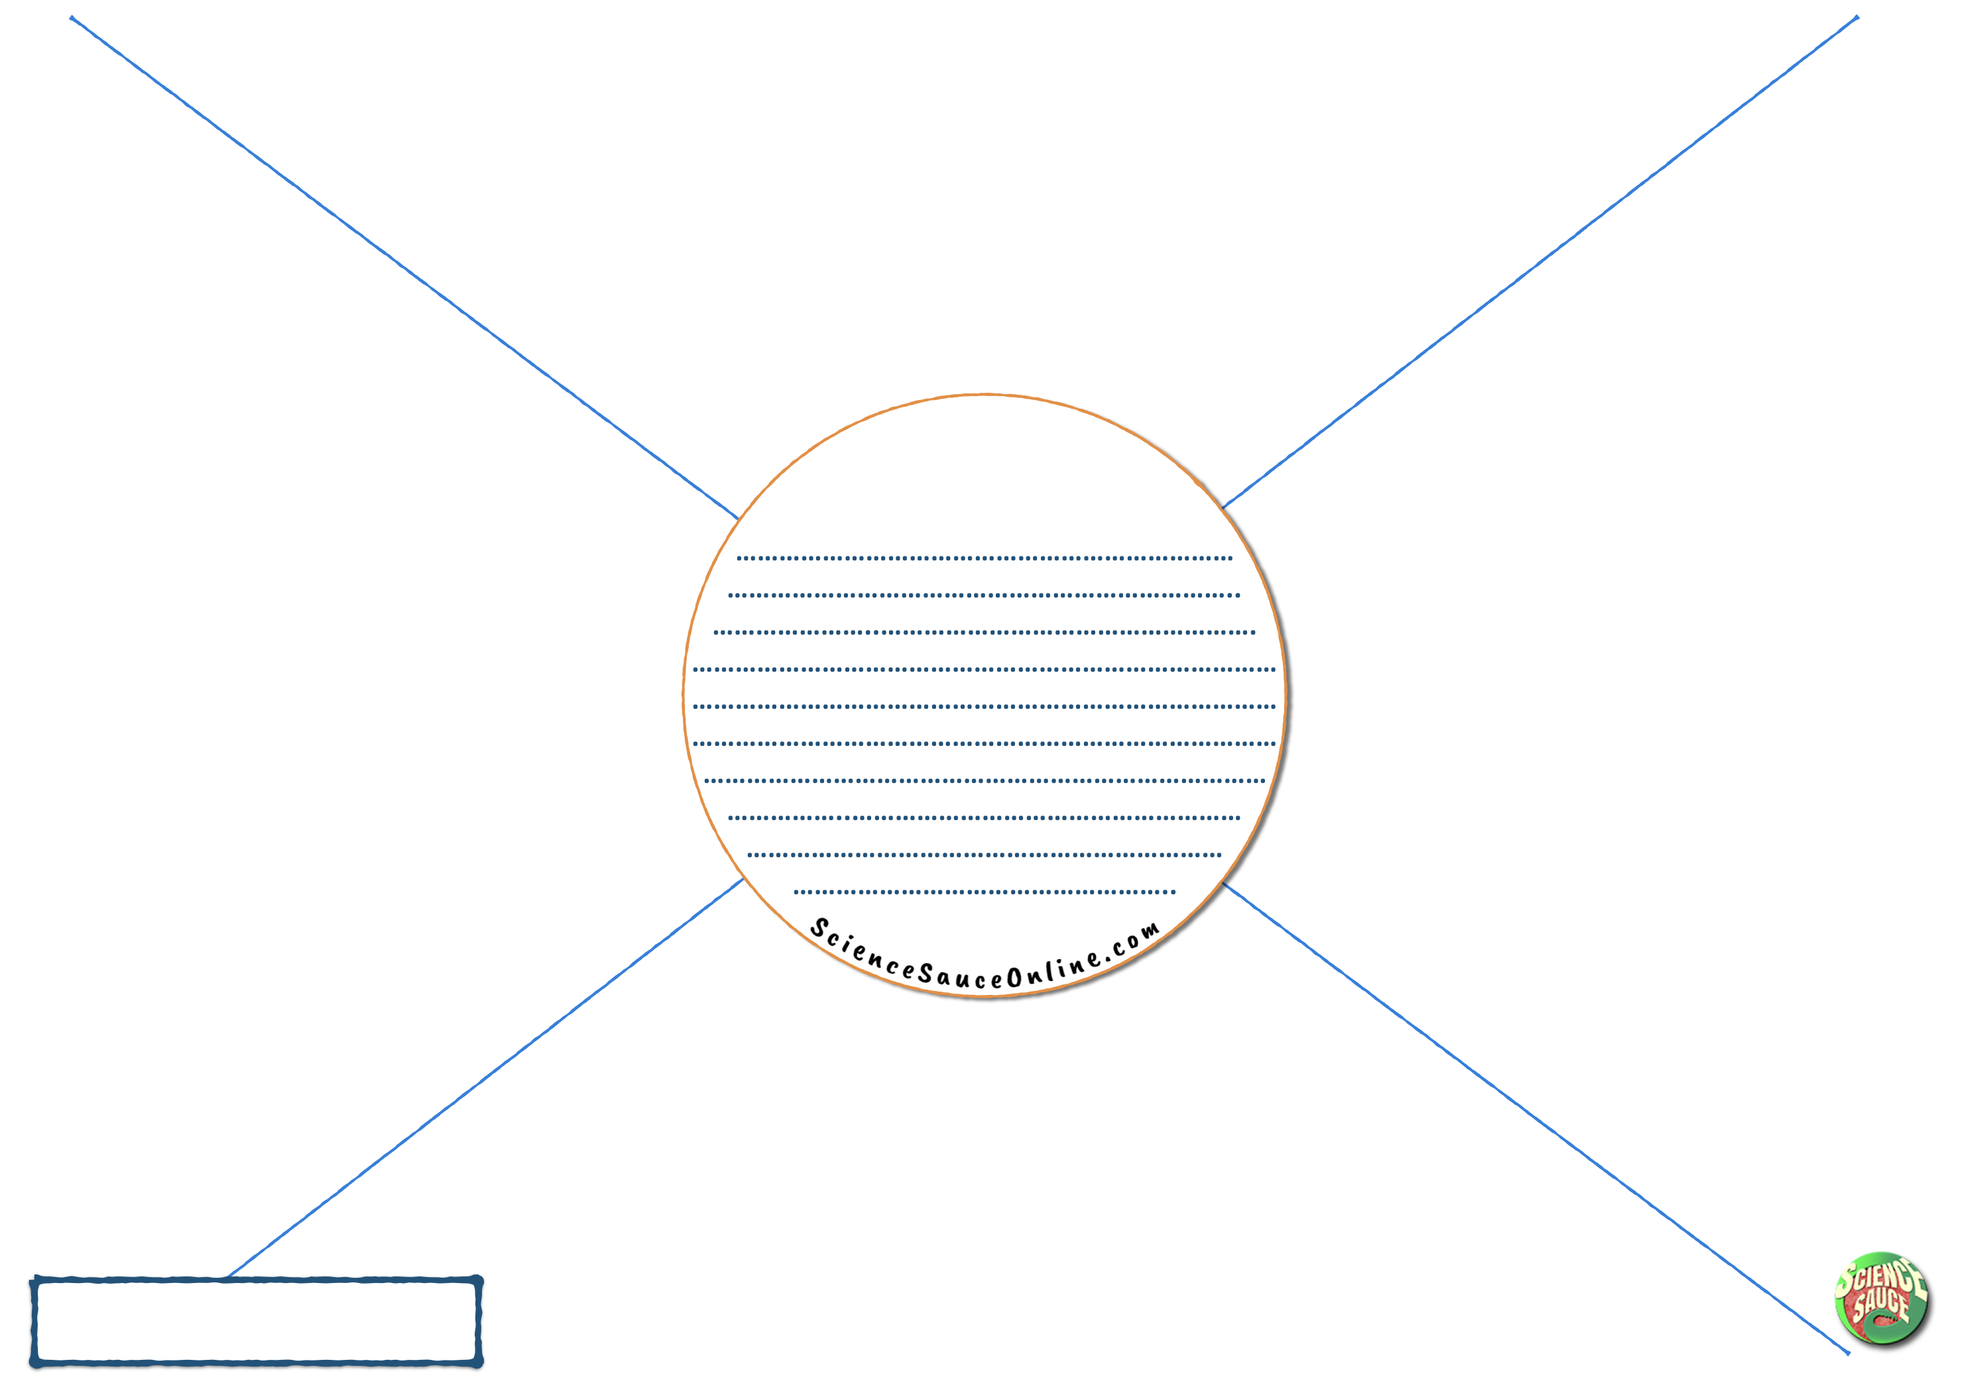

Delete this text and add your own summary question here.

**Your Lesson Title**

Add text boxes to put your questions on the sheet.